Pandas (Python Data Analysis Library)
- Creating Data Frames
Aim: To create a Pandas DataFrame from a dictionary and display its contents, data types, and statistical summary.
Algorithm:
- Import the Pandas library.
- Create a dictionary containing Name, Age, and City.
- Convert the dictionary into a DataFrame using pd.DataFrame().
- Display the first five rows using df.head().
- Display column information using df.info().
- Display the statistical summary using df.describe().
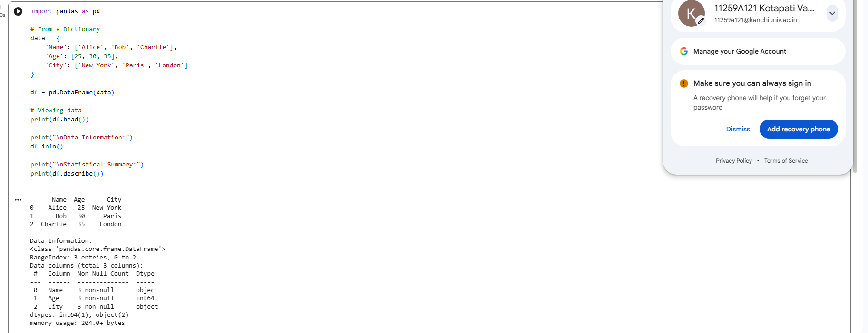
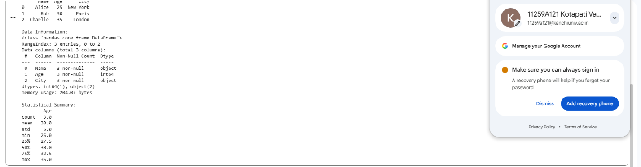
Result: Thus, a Pandas DataFrame was created successfully, and its contents, data types, and statistical summary were displayed.

- Selecting and Filtering
Aim: To select columns, filter rows based on a condition, and access specific rows and values using iloc and loc in Pandas.
Algorithm:
- Use the DataFrame created in Program 1.
- Select the Age column using df['Age'].
- Filter people whose age is greater than 25 using df[df['Age'] > 25].
- Retrieve the first row using df.iloc[0].
- Retrieve the name at index 0 using df.loc[0, 'Name'].
- Display the selected column, filtered rows, first row, and specific value.
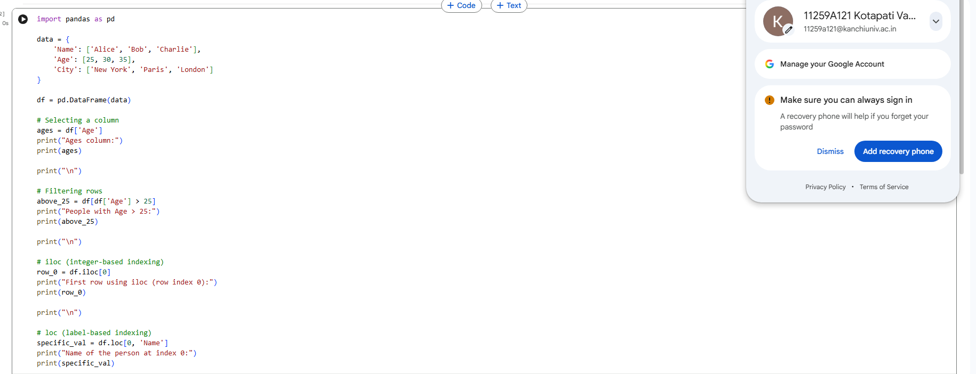

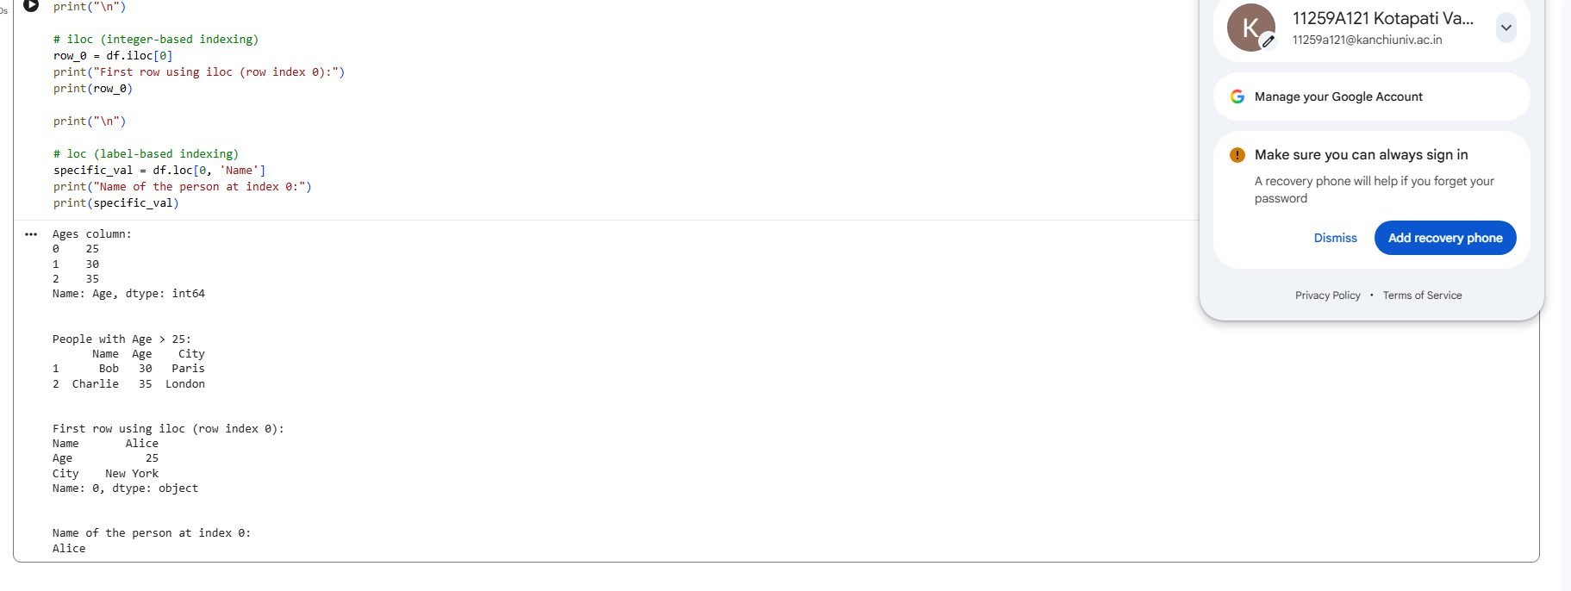
Result: Thus, column selection, conditional row filtering, integer-based indexing using iloc, and label-based indexing using loc were performed successfully.

- Data Cleaning (Handling Missing Values)
Aim: To identify and handle missing values in a Pandas DataFrame using isnull(), dropna(), and fillna().
Algorithm:
- Import the Pandas and NumPy libraries.
- Create a dictionary containing Name, Age, and City with missing values represented by np.nan.
- Convert the dictionary into a DataFrame.
- Display the original DataFrame.
- Count missing values in each column using df.isnull().sum().
- Remove rows containing missing values using df.dropna().
- Replace all missing values with zero using df.fillna(0).
- Calculate the mean of the Age column and fill missing ages with the mean.
- Replace missing values in the City column with "Unknown".
- Display the results of each operation.
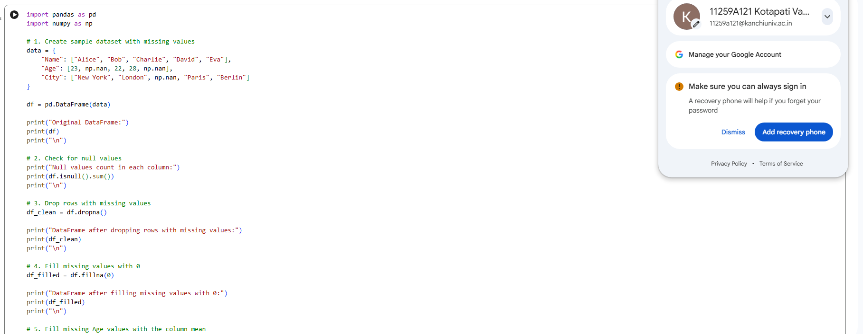

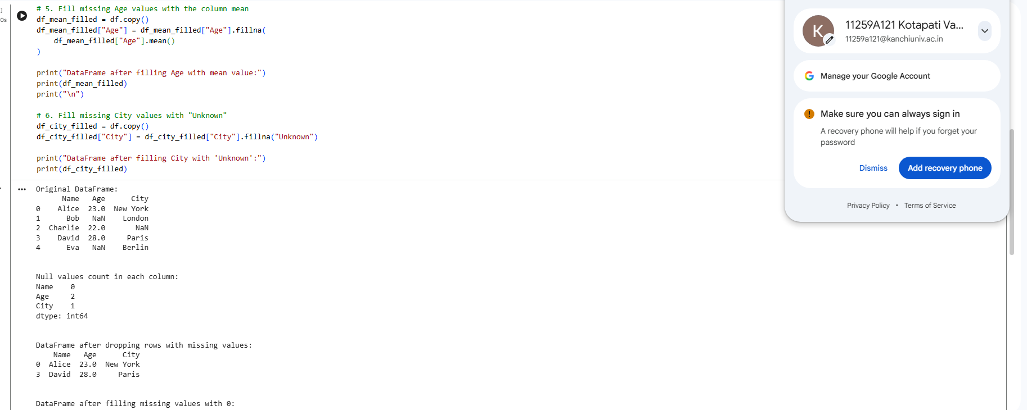

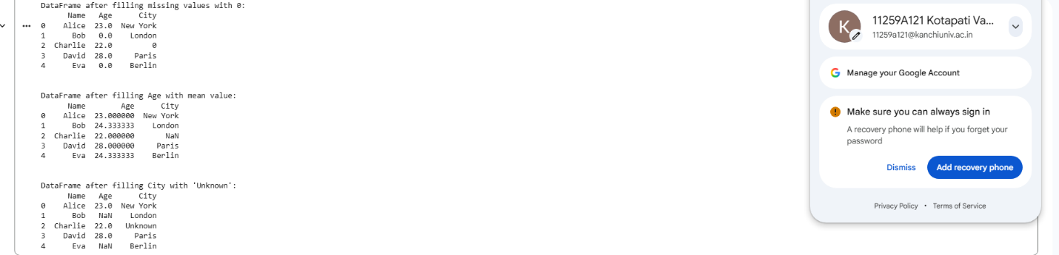
Result: Thus, missing values were identified and handled successfully by removing incomplete rows, replacing missing values with zero, filling missing ages with the column mean, and replacing missing city values with "Unknown".

